Claudia V Dominguez
Due: May 17 2026

Description:
Developed a full-stack construction material tracking system to streamline inventory management across multiple job sites, enabling real-time visibility into material availability and reducing delays caused by stock shortages. The application features QR code-based material identification using html5-qrcode, allowing users to quickly scan, locate, and update inventory directly from the interface.
Built the frontend using Next.js, TypeScript, Tailwind CSS, and shadcn/ui to create a responsive and user-friendly dashboard, with form handling and validation implemented through React Hook Form and Zod. Designed and implemented backend logic using Next.js server actions and route handlers, supporting core workflows such as inventory transactions, material requests, and approval processes.
Integrated Supabase Auth for secure user authentication and role-based access control, and Supabase Storage for managing material images and file uploads. Developed automated low-stock alerting using Supabase Edge Functions and Resend to trigger email notifications when inventory falls below defined thresholds.
Designed a normalized relational database schema using PostgreSQL and Prisma ORM to support scalable tracking of materials, inventory transactions, project-based stock, and request workflows.

Tech Stack/Tools
- Frontend: Next.js, TypeScript, Tailwind CSS, shadcn/ui
- Backend: Next.js Server Actions, Route Handlers
- Database: PostgreSQL
- ORM: Prisma
- Authentication: Supabase Auth
- Storage: Supabase Storage
- Serverless / Alerts: Supabase Edge Functions
- Forms & Validation: React Hook Form, Zod
- Email Notifications: Resend
- QR Code Scanning: html5-qrcode
Construction Tracker System : Use Case

Worker --------> (Log in)
Worker --------> (View Materials)
Worker --------> (Scan QR Code)
Worker --------> (Submit Material Request)
Worker --------> (View Request Status)

Manager -------> (Log in)
Manager -------> (View Dashboard)
Manager -------> (Monitor Inventory)
Manager -------> (Approve/Reject Requests)
Manager -------> (Update Inventory)
Manager -------> (View Alerts)

Admin ---------> (Log in)
Admin ---------> (Manage Users)
Admin ---------> (Manage Materials)
Admin ---------> (Manage Projects)
Admin ---------> (View Transactions)
Admin ---------> (Configure Alerts)
Admin ---------> (Upload Files)

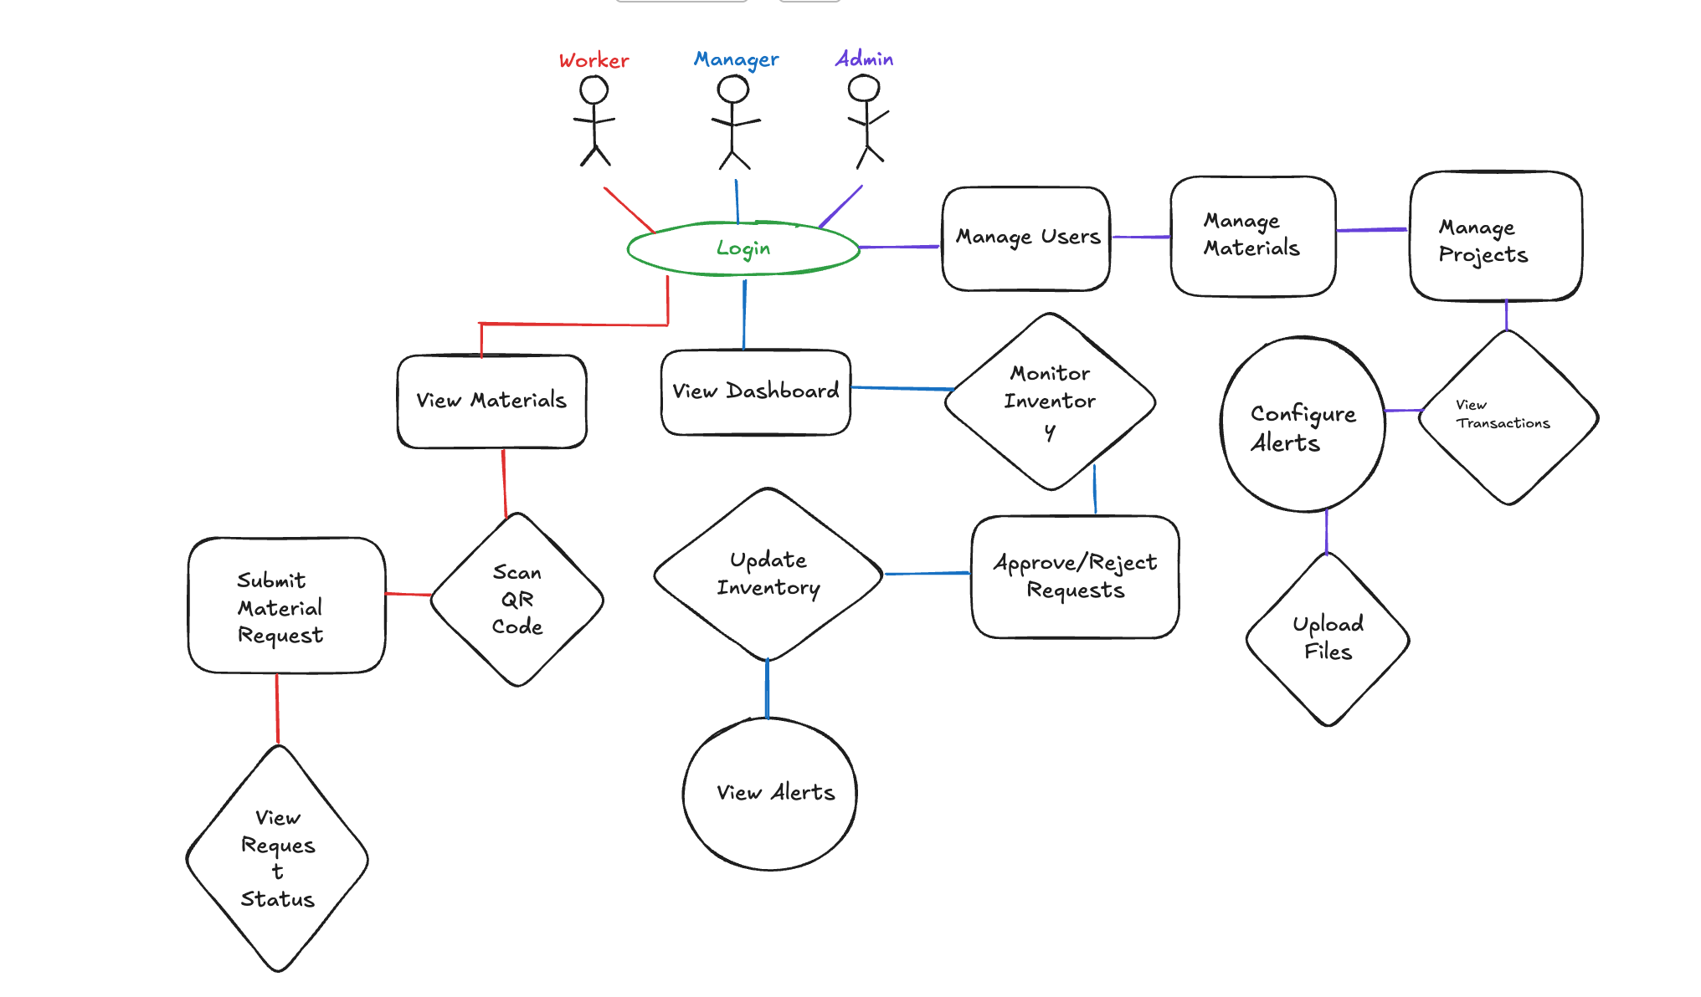
UI Flow Diagram (User Flow)

[Login Page]
↓
[Dashboard]
├── [Materials Page]
│ ├── [Material Details]
│ └── [Add/Edit Material]
│
├── [Inventory Page]
│ ├── [Stock In/Out]
│ └── [Transaction History]
│
├── [Requests Page]
│ ├── [Create Request]
│ └── [Request Status]
│
├── [Alerts Page]
│ └── [Low Stock Alerts]
│
└── [QR Scan Page]
↓
[Material Details]

Main Flow:

Worker: Login → Dashboard → Scan QR → Material Details → Submit Request
Manager: Login → Dashboard → Requests → Approve/Reject → Update Inventory
Admin: Login → Dashboard → Manage Users / Materials / Projects

UI Design:

ERD Diagram:

Table User {
id string [pk]
email string [unique]
fullName string
role string
phone string
isActive boolean
createdAt datetime
}

Table Project {
id string [pk]
name string
location string
startDate datetime
endDate datetime
status string
managerId string
}

Table Supplier {
id string [pk]
name string
contactName string
phone string
email string
}

Table MaterialCategory {
id string [pk]
name string
description string
}

Table Material {
id string [pk]
name string
categoryId string
supplierId string
unit string
costPerUnit float
minThreshold int
qrCode string [unique]
createdAt datetime
}

Table Inventory {
id string [pk]
materialId string
projectId string
quantity int
lastUpdated datetime
}

Table InventoryTransaction {
id string [pk]
materialId string
projectId string
userId string
type string
quantity int
note string
createdAt datetime
}

Table MaterialRequest {
id string [pk]
userId string
projectId string
status string
priority string
createdAt datetime
}

Table MaterialRequestItem {
id string [pk]
requestId string
materialId string
quantity int
}

Table Alert {
id string [pk]
materialId string
projectId string
type string
message string
isResolved boolean
createdAt datetime
}

Table FileUpload {
id string [pk]
materialId string
url string
fileType string
uploadedAt datetime
}

Ref: Project.managerId > User.id

Ref: Material.categoryId > MaterialCategory.id
Ref: Material.supplierId > Supplier.id

Ref: Inventory.materialId > Material.id
Ref: Inventory.projectId > Project.id

Ref: InventoryTransaction.materialId > Material.id
Ref: InventoryTransaction.projectId > Project.id
Ref: InventoryTransaction.userId > User.id

Ref: MaterialRequest.userId > User.id
Ref: MaterialRequest.projectId > Project.id

Ref: MaterialRequestItem.requestId > MaterialRequest.id
Ref: MaterialRequestItem.materialId > Material.id

Ref: Alert.materialId > Material.id
Ref: Alert.projectId > Project.id

Ref: FileUpload.materialId > Material.id

